Intro to Java Week 6 Coding Assignment

**Points possible:** 70

|  |  |  |
| --- | --- | --- |
| Category | Criteria | % of Grade |
| Functionality | Does the code work? | 25 |
| Organization | Is the code clean and organized? Proper use of white space, syntax, and consistency are utilized. Names and comments are concise and clear. | 25 |
| Creativity | Student solved the problems presented in the assignment using creativity and out of the box thinking. | 25 |
| Completeness | All requirements of the assignment are complete. | 25 |

**Instructions:** In Eclipse, or an IDE of your choice, write the code that accomplishes the objectives listed below. Ensure that the code compiles and runs as directed. Take screenshots of the code and of the running program (make sure to get screenshots of all required functionality) and paste them in this document where instructed below. Create a new repository on GitHub for this week’s assignments and push this document, with your Java project code, to the repository. Add the URL for this week’s repository to this document where instructed and submit this document to your instructor when complete.

**Coding Steps:**

For the final project you will be creating an automated version of the classic card game *WAR.*

1. Create the following classes.
   1. Card
      1. Fields
         1. **value** (contains a value from 2-14 representing cards 2-Ace)
         2. **name** (e.g. Ace of Diamonds, or Two of Hearts)
      2. Methods
         1. Getters and Setters
         2. **describe** (prints out information about a card)
   2. Deck
      1. Fields
         1. **cards** (List of Card)
      2. Methods
         1. **shuffle** (randomizes the order of the cards)
         2. **draw** (removes and returns the top card of the Cards field)
         3. In the constructor, when a new Deck is instantiated, the Cards field should be populated with the standard 52 cards.
   3. Player
      1. Fields
         1. **hand** (List of Card)
         2. **score** (set to 0 in the constructor)
         3. **name**
      2. Methods
         1. **describe** (prints out information about the player and calls the describe method for each card in the Hand List)
         2. **flip** (removes and returns the top card of the Hand)
         3. **draw** (takes a Deck as an argument and calls the draw method on the deck, adding the returned Card to the hand field)
         4. **incrementScore** (adds 1 to the Player’s score field)
2. Create a class called App with a main method.
3. Instantiate a Deck and two Players, call the shuffle method on the deck.
4. Using a traditional for loop, iterate 52 times calling the Draw method on the other player each iteration using the Deck you instantiated.
5. Using a traditional for loop, iterate 26 times and call the flip method for each player.
   1. Compare the value of each card returned by the two player’s flip methods. Call the incrementScore method on the player whose card has the higher value.
6. After the loop, compare the final score from each player.
7. Print the final score of each player and either “Player 1”, “Player 2”, or “Draw” depending on which score is higher or if they are both the same.

**Screenshots of Code:**

Card Class:

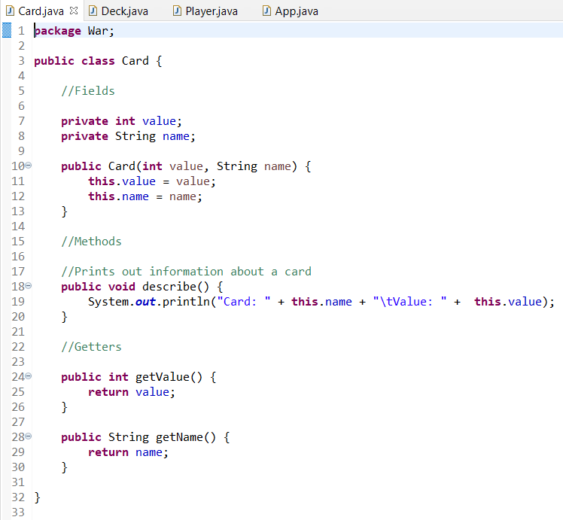

Deck Class:

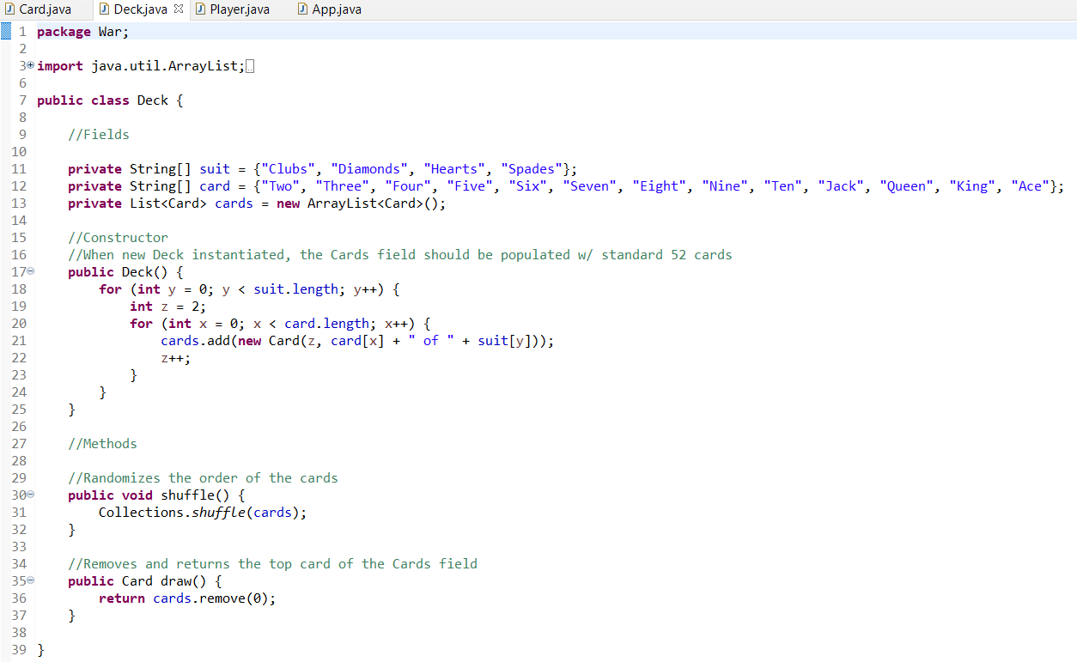

Player Class:

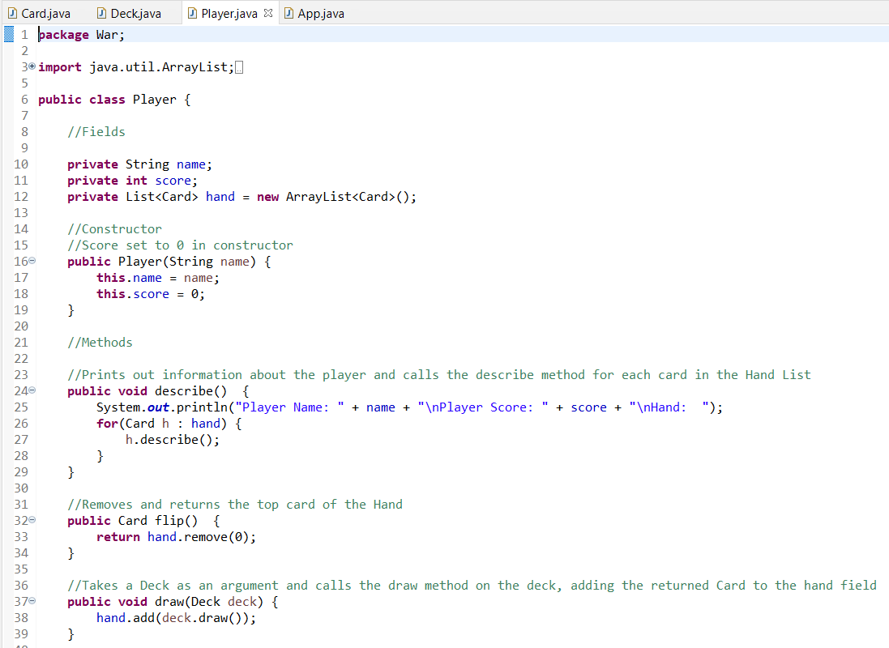

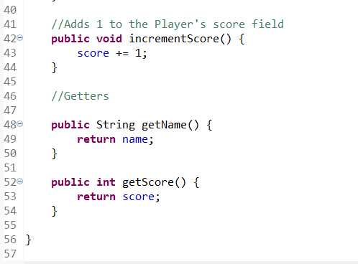

App Class:

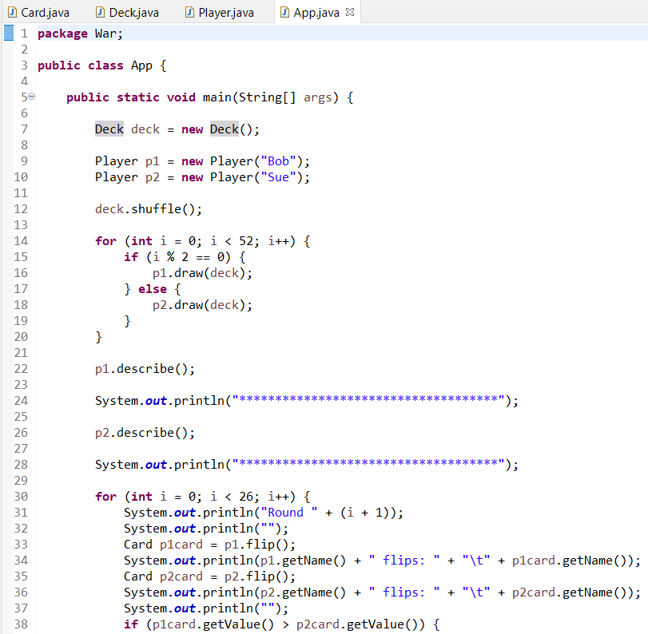

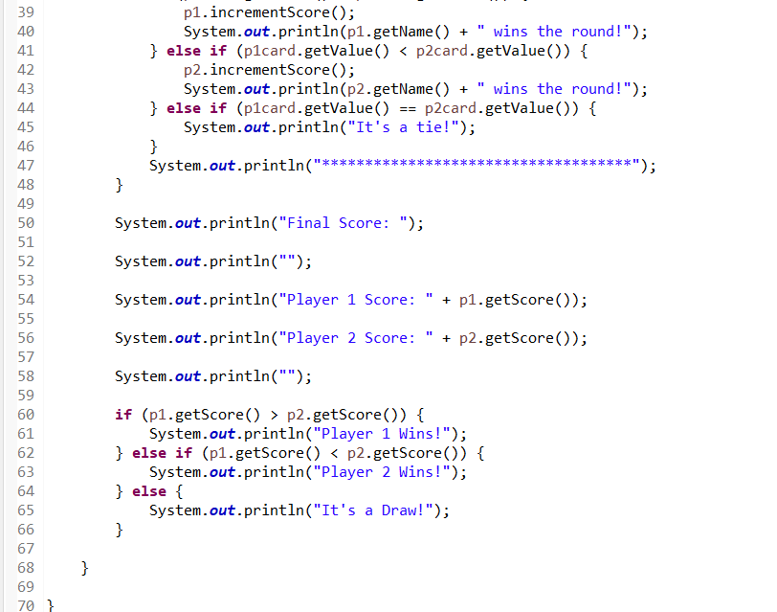

**Screenshots of Running Application:**

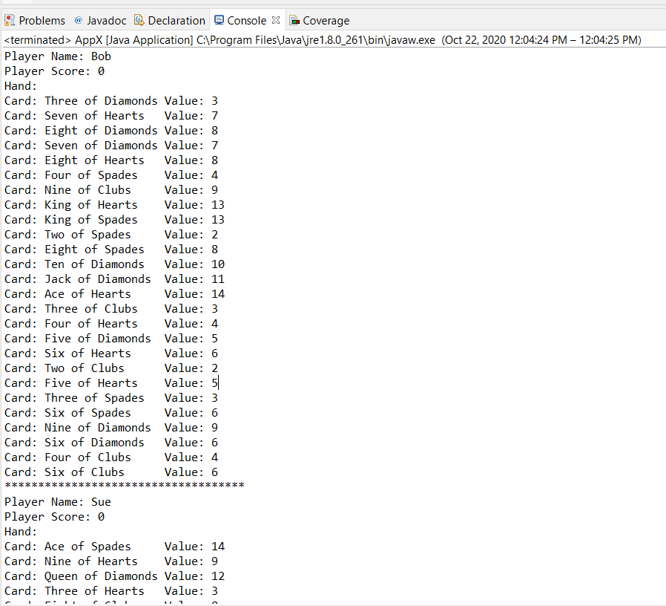

Player Name: Bob

Player Score: 0

Hand:

Card: Three of Diamonds Value: 3

Card: Seven of Hearts Value: 7

Card: Eight of Diamonds Value: 8

Card: Seven of Diamonds Value: 7

Card: Eight of Hearts Value: 8

Card: Four of Spades Value: 4

Card: Nine of Clubs Value: 9

Card: King of Hearts Value: 13

Card: King of Spades Value: 13

Card: Two of Spades Value: 2

Card: Eight of Spades Value: 8

Card: Ten of Diamonds Value: 10

Card: Jack of Diamonds Value: 11

Card: Ace of Hearts Value: 14

Card: Three of Clubs Value: 3

Card: Four of Hearts Value: 4

Card: Five of Diamonds Value: 5

Card: Six of Hearts Value: 6

Card: Two of Clubs Value: 2

Card: Five of Hearts Value: 5

Card: Three of Spades Value: 3

Card: Six of Spades Value: 6

Card: Nine of Diamonds Value: 9

Card: Six of Diamonds Value: 6

Card: Four of Clubs Value: 4

Card: Six of Clubs Value: 6

************************************

Player Name: Sue

Player Score: 0

Hand:

Card: Ace of Spades Value: 14

Card: Nine of Hearts Value: 9

Card: Queen of Diamonds Value: 12

Card: Three of Hearts Value: 3

Card: Eight of Clubs Value: 8

Card: Jack of Clubs Value: 11

Card: Queen of Spades Value: 12

Card: King of Diamonds Value: 13

Card: Jack of Hearts Value: 11

Card: Five of Clubs Value: 5

Card: Ace of Clubs Value: 14

Card: Ten of Clubs Value: 10

Card: Seven of Clubs Value: 7

Card: Four of Diamonds Value: 4

Card: Queen of Hearts Value: 12

Card: King of Clubs Value: 13

Card: Queen of Clubs Value: 12

Card: Five of Spades Value: 5

Card: Two of Diamonds Value: 2

Card: Nine of Spades Value: 9

Card: Seven of Spades Value: 7

Card: Jack of Spades Value: 11

Card: Ten of Spades Value: 10

Card: Two of Hearts Value: 2

Card: Ten of Hearts Value: 10

Card: Ace of Diamonds Value: 14

************************************

Round 1

Bob flips: Three of Diamonds

Sue flips: Ace of Spades

Sue wins the round!

************************************

Round 2

Bob flips: Seven of Hearts

Sue flips: Nine of Hearts

Sue wins the round!

************************************

Round 3

Bob flips: Eight of Diamonds

Sue flips: Queen of Diamonds

Sue wins the round!

************************************

Round 4

Bob flips: Seven of Diamonds

Sue flips: Three of Hearts

Bob wins the round!

************************************

Round 5

Bob flips: Eight of Hearts

Sue flips: Eight of Clubs

It's a tie!

************************************

Round 6

Bob flips: Four of Spades

Sue flips: Jack of Clubs

Sue wins the round!

************************************

Round 7

Bob flips: Nine of Clubs

Sue flips: Queen of Spades

Sue wins the round!

************************************

Round 8

Bob flips: King of Hearts

Sue flips: King of Diamonds

It's a tie!

************************************

Round 9

Bob flips: King of Spades

Sue flips: Jack of Hearts

Bob wins the round!

************************************

Round 10

Bob flips: Two of Spades

Sue flips: Five of Clubs

Sue wins the round!

************************************

Round 11

Bob flips: Eight of Spades

Sue flips: Ace of Clubs

Sue wins the round!

************************************

Round 12

Bob flips: Ten of Diamonds

Sue flips: Ten of Clubs

It's a tie!

************************************

Round 13

Bob flips: Jack of Diamonds

Sue flips: Seven of Clubs

Bob wins the round!

************************************

Round 14

Bob flips: Ace of Hearts

Sue flips: Four of Diamonds

Bob wins the round!

************************************

Round 15

Bob flips: Three of Clubs

Sue flips: Queen of Hearts

Sue wins the round!

************************************

Round 16

Bob flips: Four of Hearts

Sue flips: King of Clubs

Sue wins the round!

************************************

Round 17

Bob flips: Five of Diamonds

Sue flips: Queen of Clubs

Sue wins the round!

************************************

Round 18

Bob flips: Six of Hearts

Sue flips: Five of Spades

Bob wins the round!

************************************

Round 19

Bob flips: Two of Clubs

Sue flips: Two of Diamonds

It's a tie!

************************************

Round 20

Bob flips: Five of Hearts

Sue flips: Nine of Spades

Sue wins the round!

************************************

Round 21

Bob flips: Three of Spades

Sue flips: Seven of Spades

Sue wins the round!

************************************

Round 22

Bob flips: Six of Spades

Sue flips: Jack of Spades

Sue wins the round!

************************************

Round 23

Bob flips: Nine of Diamonds

Sue flips: Ten of Spades

Sue wins the round!

************************************

Round 24

Bob flips: Six of Diamonds

Sue flips: Two of Hearts

Bob wins the round!

************************************

Round 25

Bob flips: Four of Clubs

Sue flips: Ten of Hearts

Sue wins the round!

************************************

Round 26

Bob flips: Six of Clubs

Sue flips: Ace of Diamonds

Sue wins the round!

************************************

Final Score:

Player 1 Score: 6

Player 2 Score: 16

Player 2 Wins!

**URL to GitHub Repository:**

https://github.com/lrod8/ProjectWeek6